EXPERIMENT 7

DQL COMMANDS (COLLEGE SCHEMA)

Aim:

* Display student id and name from the student table.
* Display faculty id and name from the faculty table.
* Display that got grade A.
* Display whose marks are less than 50.
* Display the female students whose marks are between 50 to 60.
* Delete the failed students.
* Display activity id and name using object.
* Display student id, faculty id using course name condition with object.
* Select department name ending with ‘E’ and faculty name ending with ‘h ’.
* Select activity having characters between ‘in’.
* Group by faculty id and display.
* Display the students list whose grade is A using having.
* Display the faculty list that is part of CSE course.
* Apply aggregate functions in student marks - max, min, sum, count, and avg.

MySQL:

SELECT studid, studname FROM student**;**

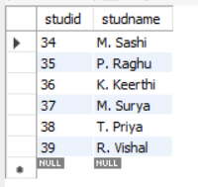

select fac_name, fac_id from faculty;

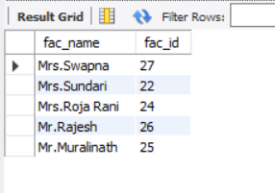

SELECT studname, grade FROM student WHERE grade = "A";

SELECT studname, marks FROM student WHERE marks < 50;

SELECT studid, studname FROM student WHERE 50 < marks < 60 and gender = "F";

DELETE FROM student WHERE grade = "E";

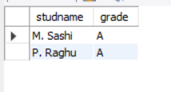

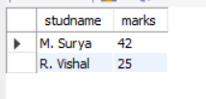

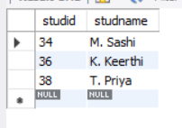

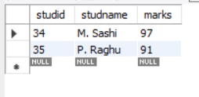

**SELECT a.act_id, a.act_name FROM activity a;**

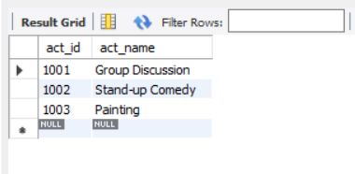

SELECT studid, fac_id FROM student s, faculty f WHERE s.course = f.course;

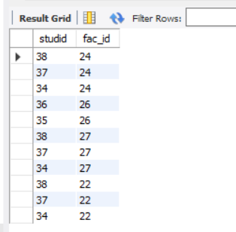

select dept_name from department where dept_name like 'E%';

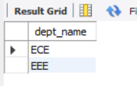

select fac_name from faculty where fac_name like '%h';

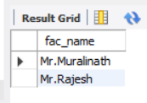

select act_name from activity where act_name like '%in%';

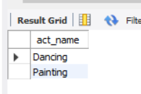

select * from faculty group by fac_id;

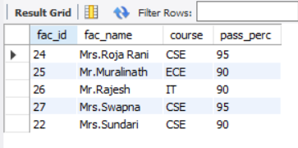

select studname, grade from student group by studname having grade = "A";

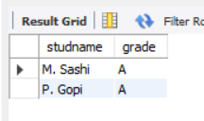

select fac_name, course from faculty group by fac_name having course = "CSE";

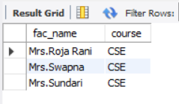

select max(marks) from student;

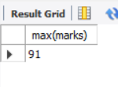

select min(marks) from student;

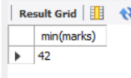

select avg(marks) from student;

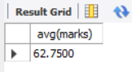

select sum(marks) from student;

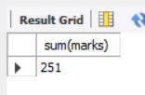

select count(marks) from student;

